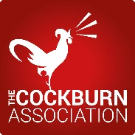 | SURVEY ON THE VIEWS OF EDINBURGH CITIZENS ABOUT THE GROWTH OF THE CITY AND ITS EFFECTS UPON THE GREEN BELT AND GREENSPACES
The Cockburn Association (Edinburgh Civic Trust) is concerned that the Scottish Government’s drive to find land for housing and development in Edinburgh and south east Scotland, will reduce the amount of important green spaces vital for the wellbeing and quality of life of people living in and around Edinburgh. In responding to a Local Authority public consultation on this matter, the Association would be grateful if you could give your views on this important matter..
Please complete this short survey and return to the Cockburn Association by Friday 28th August 2015:
By email: director@cockburnassociation.org.uk Or paper copy to: Trunks Close, 55 High Street, Edinburgh EH11SR

1. Edinburgh is a compact city of 105sq. miles with a population of nearly 500,000 people. Please indicate your view on how much bigger it should grow.

No expansion | Small expansion | Moderate expansion | Large expansion
0 sq.miles | 0-10sq.miles | 10-20sq.miles | Over 20sq.miles

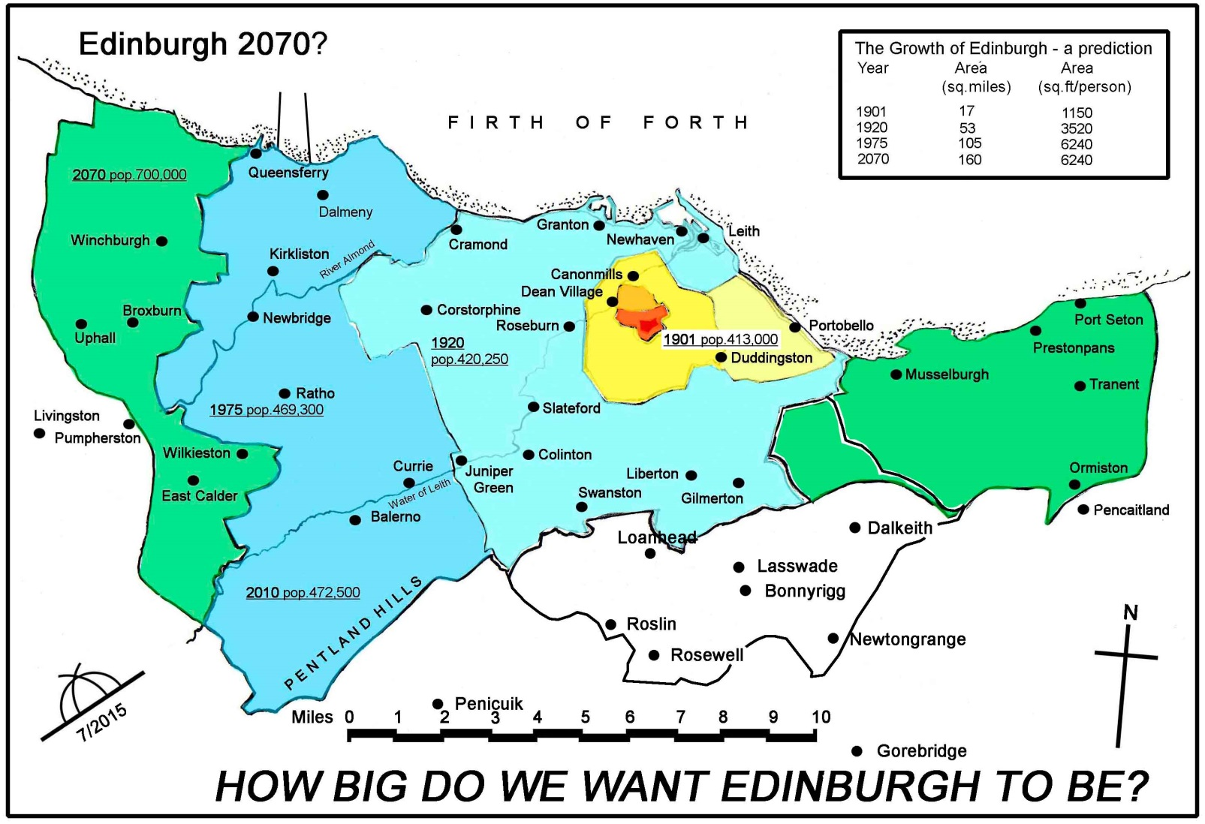
(Illustrative growth)

2. Please tick your view on whether growth should be distributed around Scotland to take any
pressure off Edinburgh and South East Scotland?

Don’t know | Keep present system | Wider distribution

- The Cockburn Association believes the Edinburgh Green Belt has influenced the growth of the city in beneficial ways and, if left intact, could continue to do so, by encouraging more use of brownfield land and building at higher densities. It also helps to protect landscapes, maintains the identity of settlements by preventing their merger, offers opportunities for recreation and contributes greatly towards a good quality of life

Please tick your view on the value of the Edinburgh Green Belt
Don't know | Not valuable | Moderately valuable | Very valuable

- The Green Belt round Edinburgh varies in width from 1/4 mile to 4.5 miles. Proposed Local Development Plans (LDP) will pierce the Green Belt at Edinburgh Airport, Brunstane, Straiton and elsewhere

Please tick the extent you believe the Green Belt should be protected.
Don't know | No stronger | Stronger | Much stronger

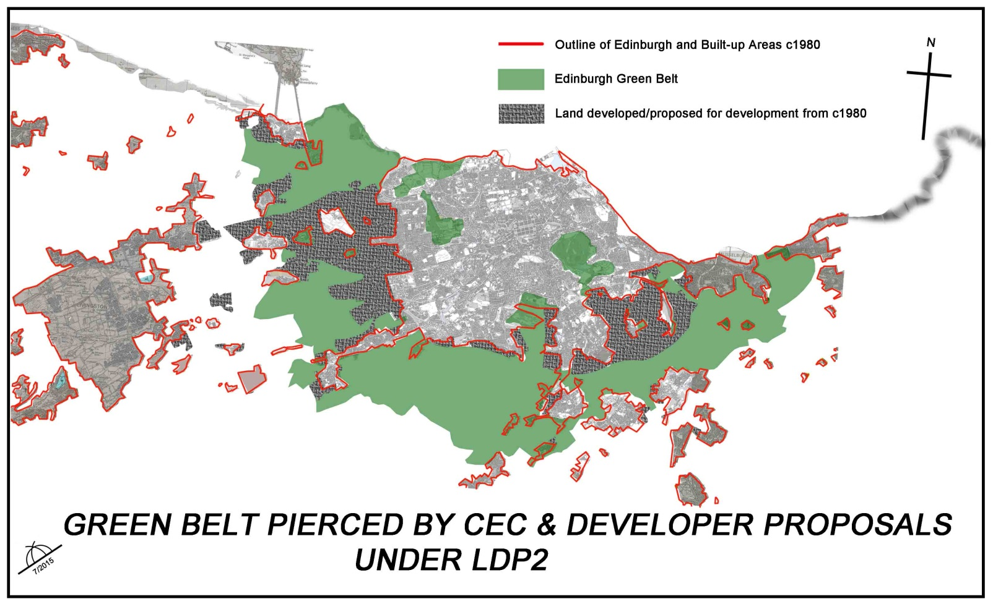
(CEC = City of Edinburgh Council; LDP2 = Local Development Plan for Edinburgh)

4. Other Comments

Please add your name and postcode.

Scottish Charity No: SC011544

